**How have the female Pentagram partners contributed to Pentagram and the design world?**

**How to the female Pentagram partners collect and disperse information.**

I**nroduction**

Pentagram has been an extremely influential collaborative studio made up of 23 partners who also serve as the business owners and designers of the company, working either independently or collaboratively. The company showcases a diverse range of specialists within design including; Natasha Jen, Paula Scher and Giorgia Lupi. This is a chance to look specifically at the work and contributions that these Pentagram partners have made to the development of design at the company.



Looking at how their designs and thinking have influenced the world today and what information or history has changed the way they process the information around them. In short, this is an insight into the stories of.

Designers at Pentagram are proud to say that they pick and choose the clients that they work with. These three designers show a real passion in the way they approach design as well as how they communicate through their work, producing intelligent design that expresses their commitment to their craft.

**Natasha Jen**



Jen is a graphic designer and a partner of Pentagram. She has been an important contributor to the world of design, using her ability to transition between media genres with ease. Jen works intrinsically across *“brand identities, environmental design, multi-scale exhibitions, signage systems, print, motion and interactive graphics, created in collaborations with universities and professional organizations, museums and galleries, and retail and fashion brands.”* <https://www.pentagram.com/about/natasha-jen> This broad approach to design application allows her to positively contribute to the development of Pentagrams portfolio but more importantly, actively engage within the wider design community. Jen states, ‘When you only use one medium as the only outlet it creates problems. Design needs a lot of information and research.’ - Natasha Jen: Design Thinking is Bullsh*t – Youtube - <https://www.youtube.com/watch?v=V8gjDsW3lsY> Jens diverse application helps her to gather this information. ‘John Hicks’ calls this process ‘practicing imput and output’. Using as much information as you can gather from various sources and experiences and using this to fuel your design perspectives.

Integrated within her individual process of designing, she references a vast array of cultural and historical influence, also paying tribute to technological developments. Such as? With this constrained focus she is able to apply herself within various areas of design, such as:

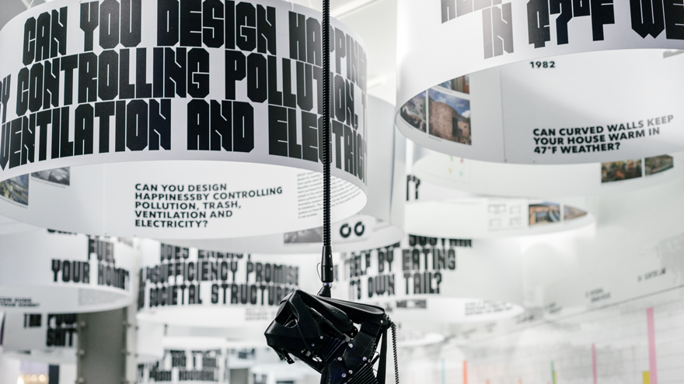

Jens contribution to the design world doesn’t just stop at her own graphic design, but also has an interest in the education and development of the next generation of designers. “Eager to pass her acumen to the next crop of young creatives, Jen has served as Board of Directors of the New York Chapter of the American Institute of Graphic Arts from 2014 to 2017. She is a faculty member at the School of Visual Arts BFA Graphic Design Program and is a guest critic at Harvard Graduate School of Design, Yale University School of Art, Cooper Union, Rhode Island School of Design, and Maryland Institute College of Art. “

<https://www.designindaba.com/articles/creative-work/natasha-jen-power-being-critical-thinker-design-world>

The development of young designers is an important area for Jen and making sure frameworks are in place so that they can develop their work and themselves in the right way is fundamental. This is why, in a talk given by Jan for ‘Design Indaba’ called ‘Design Thinking is Bullsh*t’, she says that “It’s about making things tangible and understandable”. Natasha Jen: Design Thinking is Bullsh*t – Youtube - <https://www.youtube.com/watch?v=V8gjDsW3lsY>. This goes for the final product but also the process for designing. Jen then goes on to talk about the notion of design thinking being too simplified. This reiterates her idea of research and information building the basis to which good design is constructed. This video caused widespread uproar in the world of design and shows is an example of the passion Jen has for making sure the foundations from which design is built from are questioned and reformed in the right way.

Jen started to look into and research the idea of design thinking as this was something she couldn’t fully understand. The more she looked into it the more outrageous it appeared to her. She states that,

IdeoU course was published and the idea of design thinking had spiked.

**Paula Scher**

The first designer we look at is Paula Scher, A specialist in Typography, working with and guiding her team to create designs for theatre, museum. ‘Scher was the first female to be offered the principal position at Pentagram in 1990’s’

"Designing the logo isn't the hard job, it's persuading a million people to use it"

Paula Scher – Quote from Abstract, The Art of Design.

“The way things that get made are really accidental and circumstantial. And that things have a life of their own.

In a talk called Do What you’ve never done before. Scher talks about the real-life interactions and processes of carrying out projects.



By carrying out talks like these, she is providing information and insights into the real world of a high-level designer. During the talk she talks about restructuring the system and changing the way the reporting happened and that “sometimes it’s not the design, sometimes it’s the people.” This is similar to what Ian Spelters had said in an interview with ‘High Resolution’. Spelter talks about designing the company in order to design effectively and maintain the right incentives. Scher later goes on to talk about a project for Pittsburgh to create a logo to get people to visit the North of Pittsburgh that is accessed under a bridge. She decided to ignore the brief and pitch them an idea where the bridge was used as a space for an art installation to draw people in rather than put people off.

Ultimately, the passion evidenced through the way Scher talks about design is the main contributor in her success as a Designer.

Scher is also drawn to educating and connecting with the wider community. One of the ways she has done this is through publications, most notably ‘Maps’ where she shows emotive examples of maps that are not geographically correct but are correct in their information and are only understandable if the viewer takes the time to read details on each map. Having an emotional connection to these maps could be a response and a connection with her father, who was a photogrammetric engineer, working for the US Geological Survey, inventing a device to obtain ‘distortion-free aerial photography.’ It was from her father that she discovered that maps were distorted.

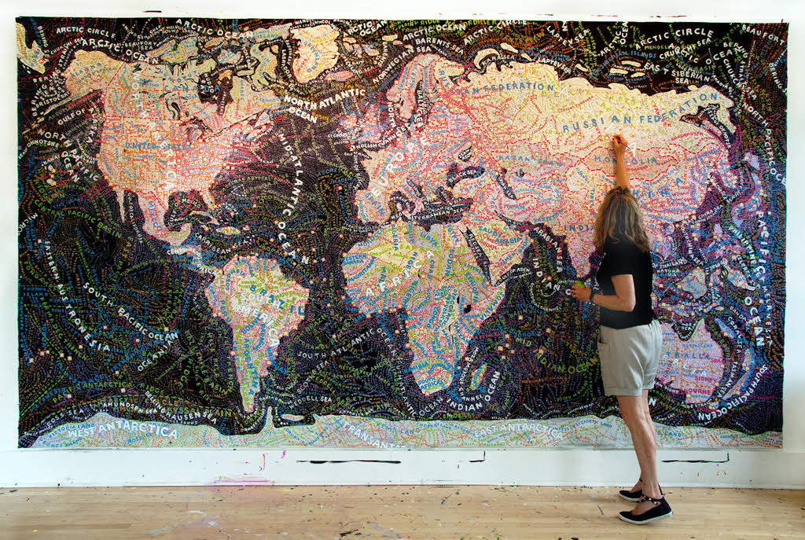

**Georgia Lupi**

Georgia Lupi is an information designer and a Partner at Pentagram.

Lupi Focuses on data and tries to communicate it in a visual form. Whilst doing this, she tries to connect the viewers with the main source of the information and the stories behind that source. Her work seems to incorporate an element of emotive response as well as simply information. She states that ‘Numbers are never the point; they are always a means to an end.” Georgia Lupi - How we can Find ourselves in Data – TED talk

<https://www.ted.com/talks/giorgia_lupi_how_we_can_find_ourselves_in_data>

‘Data power the experience but it’s the stories of human beings that are the drive.’



Lupi collaborated on a project where herself and a fellow designer, Stephanie Posavec, communicated using only data, no technology, only through postcards. Creating a key on one side, much like a map, provided the other party with a reference point to visually understand the marks and drawings on the reverse side of the postcard. This data showed the day-to-day happenings of each designer, providing a simplified, accurate and detailed analysis that would be more difficult to communicate simply using words and actually creates a much more emotional response when reading each postcard, providing a *‘lens’* into the life of that designer.

<http://www.stefanieposavec.com> – Stephanie Posavec.

This is a really interesting and creative approach to looking at design, not only focusing on the construction of the design but also training yourself to be analytical and unpick or decode the messages.

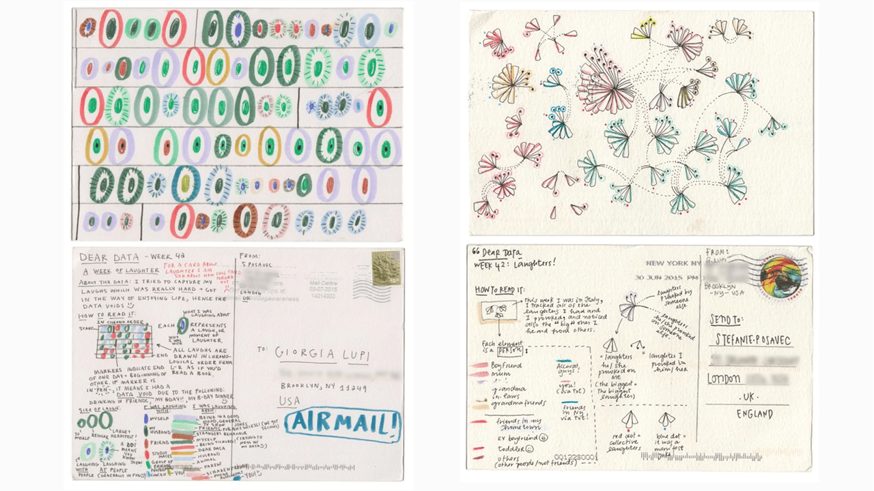

This project along with many other work

**Educating**

A conclusion

Pentagram has been an extremely influential collective, especially with the involvement of these three female Partners. They shine light on areas of importance within design and helping companies to establish a visual language, an identity and a place within design. Their contributions didn’t stop here. Making further meaningful contributions to educating designers and general public through written and visual information and making design accessible. It is important to pay tribute to these three designers because they encompass what not just what young female designers hope to achieve but also male designers like myself. They are an integral part of Pentagram and have evidenced positive contributions to the world of design.

The way in which all three designers apply themselves points to the conclusion that great design cannot be created from a narrow focus. In order to produce meaningful design, there must first be a passion. Following this, a willingness to engage with any area that suits the design appropriately and allows it to develop. The work of these designers also depict a clear statement; that design is visual first and informative later.

**Bibliography**

<https://guides.library.ulster.ac.uk/ld.php?content_id=28291696>

500 word crit with kyle.

Mention the influences on each of the designers work but also show the work itself and how this these influences have impacted the work itself. Use photos as references as well to back up ideas.

In the conclusion, be evaluative and reflective, and show what I have taken away from this and how it will impact my future endeavours.

References, use incite references and use a generator to make the in text cite and reference for bibliography.

Pentagram conviction, *‘Great design cannot happen without passion, intelligence and — above all — personal commitment’*